**Telecommunication Management Database System**

INFO 5707 Section 005: Data Modeling for Information Professionals

**Final Project Report**

Kamini Suresh Yelamar

**Abstract:**

The Telecommunication management system aims to create a database system that efficiently manages customer's telecom services. The system will contain multiple relational tables, allowing customer representatives to view and manage their network and service. Handling large amounts of telecom data can be a tedious task. This system will provide a solution to handle, store, and manage large amounts of data with accuracy ensuring that all required data is present in the table. Customers will be able to view their account information, billing history, and usage, explore various plans, and submit feedback. The system will manage billing and payment processing, including invoicing. MySQL is an excellent choice for the project, given its open-source, flexible, and powerful database management system. Overall, this Telecommunication management system will be a useful tool for both providers and customers to avail telecom services effortlessly.

**Keywords:** Database Management Systems (DBMS); Telecommunication

**Introduction:**

The Telecommunication Management Network (TMN) can be considered to be a supporting entity and framework that equips management with flexible and efficient ways to manage the day-to-day activities associated with operating telecommunications networks and services.

A Telecommunication Management Database System (TMDS) is a software solution designed to manage and streamline various aspects of telecommunications operations. It is used by telecommunications companies to track and manage their network infrastructure, customer information, billing and revenue, inventory, and other critical components of their business.

The TMDS is a powerful tool that allows telecommunications companies to improve their operational efficiency, reduce costs, and enhance customer service. With the ability to store and manage vast amounts of data, it provides a centralized platform for managing all aspects of a telecommunications operation.

The TMDS system can be used by various stakeholders in the organization, including IT managers, network administrators, and financial managers. It helps to streamline communication, improve efficiency, and reduce costs associated with telecommunication services. With the help of the TMDS system, organizations can monitor and analyze their telecommunication usage patterns, identify areas for improvement, and make data-driven decisions to optimize their communication infrastructure.

In this digital age where communication plays a vital role in organizational success, a TMDS system is essential for managing telecommunication operations effectively. This system not only helps to manage communication assets but also ensures that the organization is utilizing these assets in the most efficient and cost-effective manner possible.

**Objective:**

The Telecommunication management system is designed to operate/manage customer’s telecom services. Aiming to create a database system which will contain tables for customer details, device, opted service/plan (Prepaid and postpaid), offer, Usage (Data, voice, and SMS), complaints reported (feedback), billing cycle, invoice, payment, employee (Customer representative), department.

This system will contain multiple Relational Tables for above mentioned details that will provide a comprehensive view of a customer representative's operations, which allows them to manage their network and service efficiently. The system will also include a blacklist option for customers with overdue payments of more than three months. Different plans will be having festival offers or some special offers for customers. Customer’s usage can be accessible to track the prepaid plan limits and postpaid plan monitoring. Each customer will be billed according to the chosen plan and usage (in case of postpaid). Once the bill is calculated, invoices will be generated and notified to the customer. So that, customer can make a payment for the invoice.

Moreover, customer representatives i.e., Employees will belong to different departments (Voice Agents, HR, Technical staff, Accounts etc.). Customers will be provided to give positive or negative feedback as per the service received.

Overall, this Telecommunication management system will be a useful tool for the providers and customers to avail Telecom service effortlessly.

**Scope:**

* The System will be able to handle, store and manage huge amounts of data with accuracy, uniformity and making sure that all the required data is present in the table.
* This database system is intended for managing telecommunication systems efficiently.
* The database system can be accessed by the network provider to manage the customer’s billing cycle, payments, reported complaints, blacklist etc.
* The system should provide access to customers for viewing available plans, offers, usage, bills and due invoices.
* The customer can make a purchase of a new available plan and change its service plan from prepaid to postpaid.
* The system will have information about employees and their respective departments.
* Usage can be checked by the provider and the customers.
* The provider will have access to make changes of false triggered entries and the customer can view changes made on usage.
* Implementation of data validation in order to avoid bad data.
* Complaints or the positive feedback given by the customer using the web application will be stored in the database.
* To investigate newly or currently available plans and services, a search mechanism that is both efficient and user-friendly will be implemented.

**User Requirements:**

* Customers should be able to view their account information, current plan, billing history, and utilization, moreover they can explore various plans including price, offers, validity and data pack.
* Customer service representatives should have view and edit access to update customer accounts if needed along with blacklisted customers.
* Information of the users such as their phone number, and email address should be validated.
* Customers should be able to raise complaints and submit feedback. Which can be used by providers to improve their services.
* The system should manage billing and payment processing, including invoicing and refunds.
* Customer representatives can enable or disable plan packages.
* Individuals can be offered the deal as long as they make a minimum payment.
* The provider of telecommunications should keep track of customers' call records.

**Business Rules:**

* Each customer can be assigned to multiple Employees, and each Employee can belong to multiple customers.
* Each customer can have only one device, and each device belongs to only one customer.
* Each customer can give multiple feedbacks, but feedback can belong to only one customer, which is stored in the feedback table.
* A customer can be added to the blacklist if they violate the terms of service or have overdue payments.
* Each customer opts for only one Plan, but one plan can be subscribed by multiple customers.
* Each customer can have multiple Billing records, but each Billing record will be under the name of one customer.
* Each Employee must belong to a department. A department can have multiple Employees.
* Each Plan can have multiple offers, and each Offer can be given to multiple plans.
* Each Billing record is associated with one or more invoices, and each invoice is generated for only one Billing record.
* Each Usage record has one plan, but each plan has multiple usage records.
* Each customer can have multiple usage records which can be accessed/monitored through Plan.
* Each Invoice is associated with multiple payments. Where each payment belongs to only one invoice.

**Tool:**

Relational databases are used in this project as the primary datasets. MySQL is used to design and create the database management system (DBMS). It was chosen because of its extensive feature set and free availability. The mentioned database system can be designed and implemented successfully by utilizing the features of MySQL Workbench.

The proposed initiative's usage of MySQL Workbench is essential since it allows for the design and implementation of a reliable.

**Revised Entity Relationship Diagram of the System:**

* Added field named **DUE_AMT** in Invoice table.
* Removed **CUST_ID** from Feedback Table
* Table name changed to **USAGE_DATA**

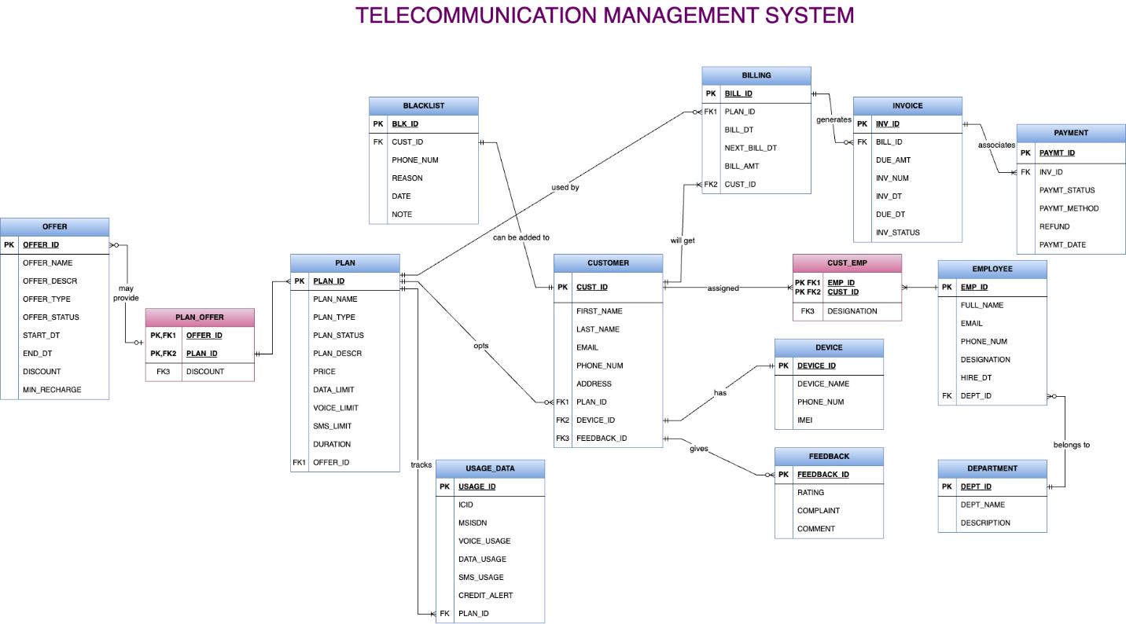

**ERD Link:** [**Group8_ERD**](https://drive.google.com/file/d/1Jq3yh2JkGtO94qi42_vNfcB9WFtGmA3o/view?usp=sharing)

**Revised Data Dictionary of the System:**

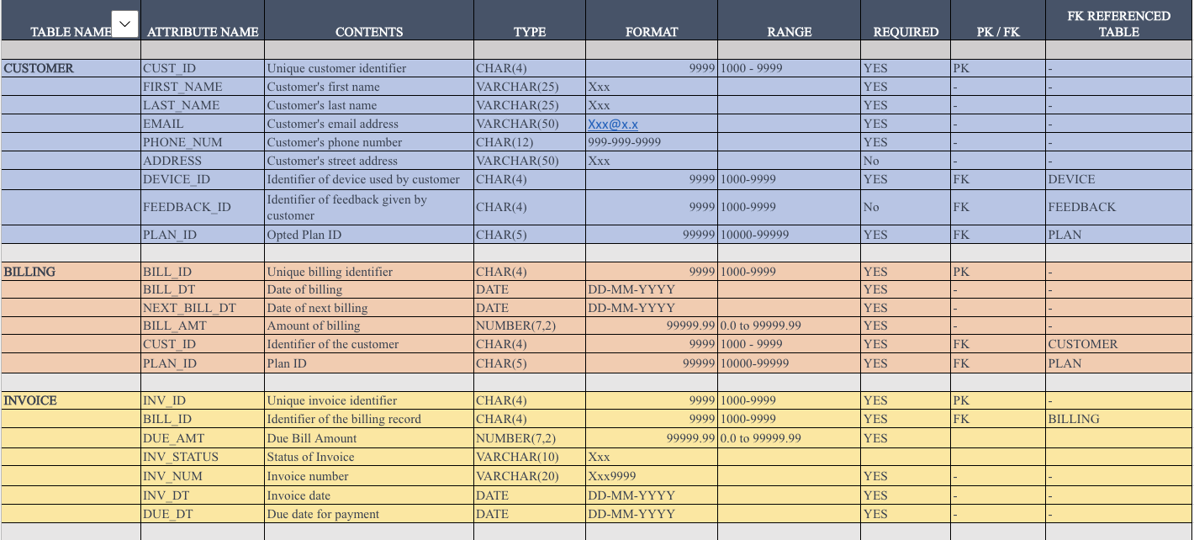

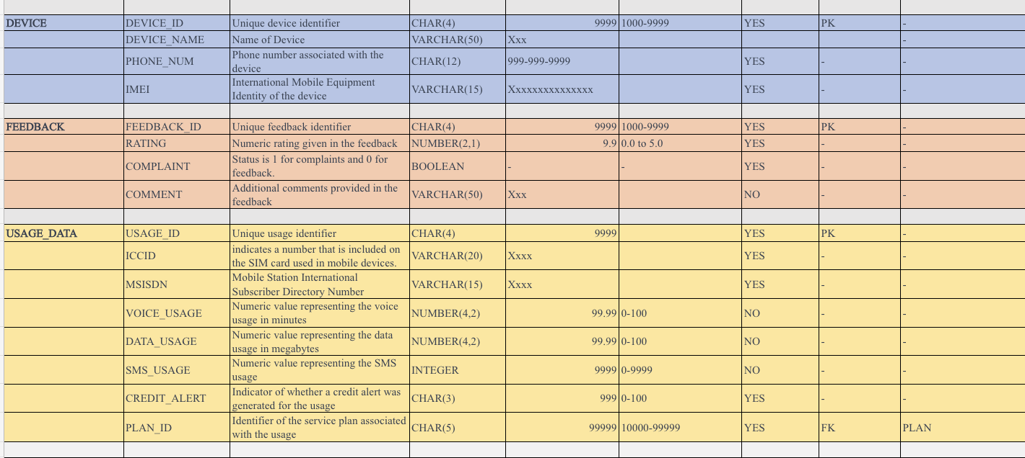

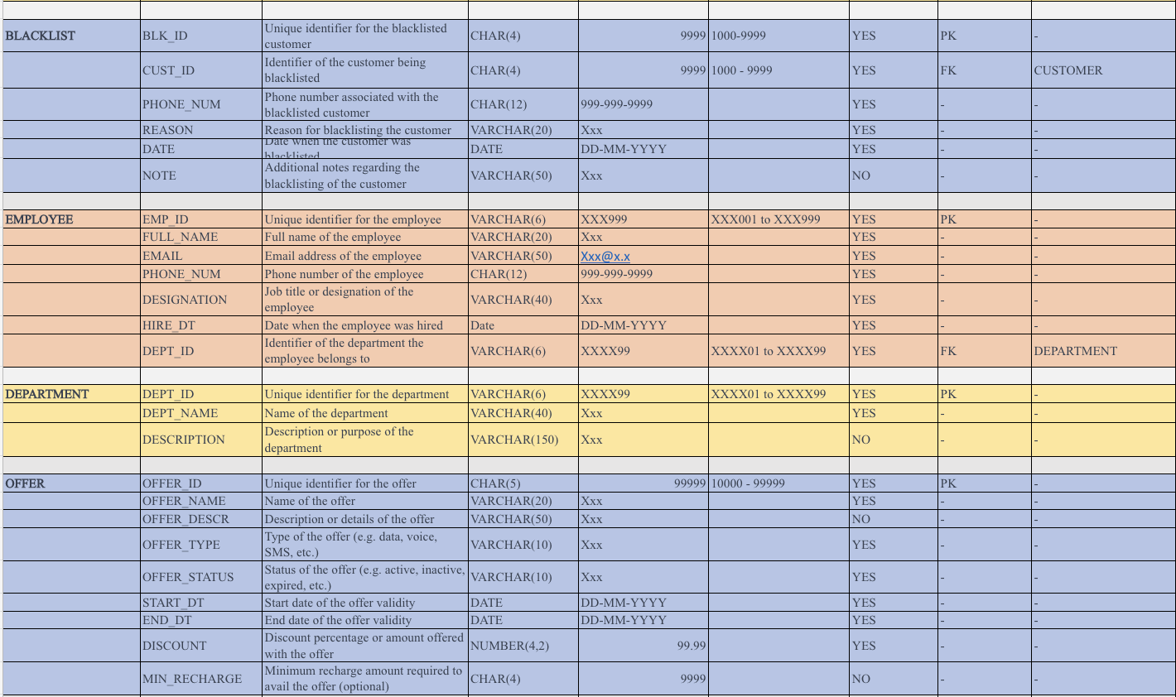

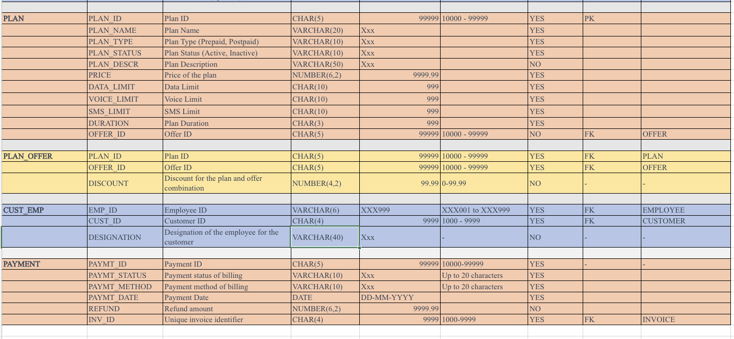

**Data Dictionary:** [**Group8_Data_Dictionary**](https://myunt-my.sharepoint.com/:x:/g/personal/kaminisureshyelamar_my_unt_edu/EUw7eyxC6sBGkiCC_Rn9AOEBGv4yFu9lLlTibU0MmN7lEA?e=gUc7XZ)

**Created a Database:**

Using MySQL Workbench, we have created a database for managing telecommunications named "Telecommunication Management".

Initialization of Database:

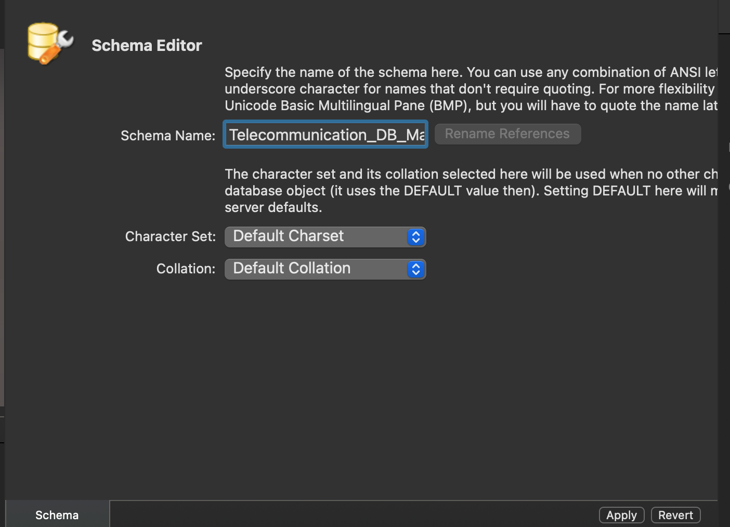

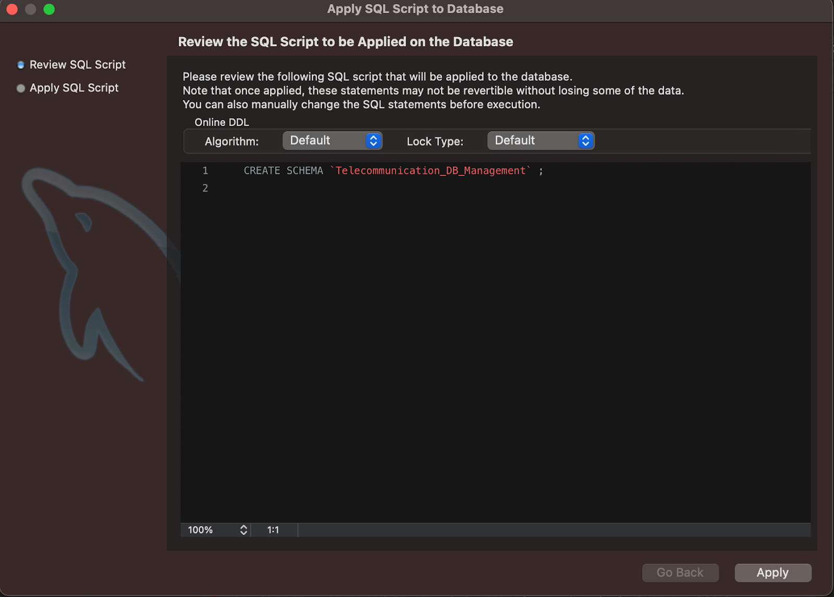

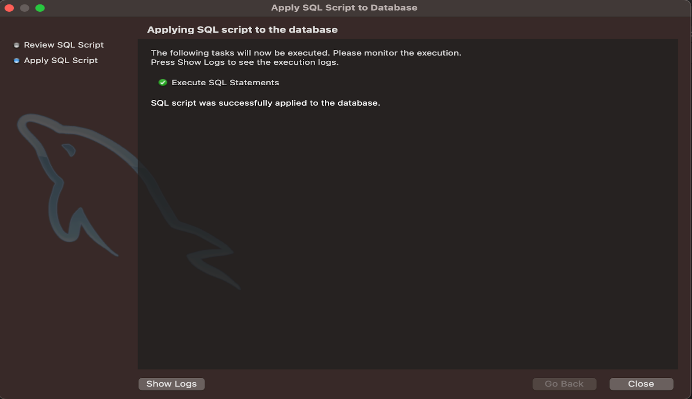

**Creating Tables in Database:**

1. **Device Table:**

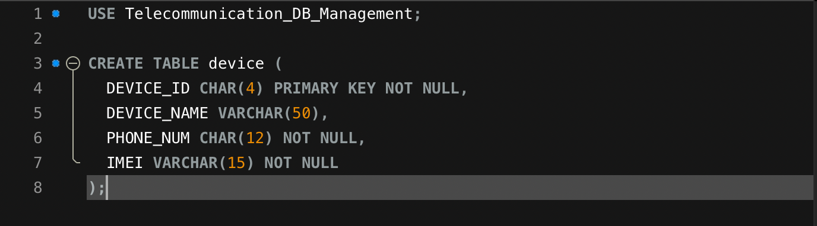

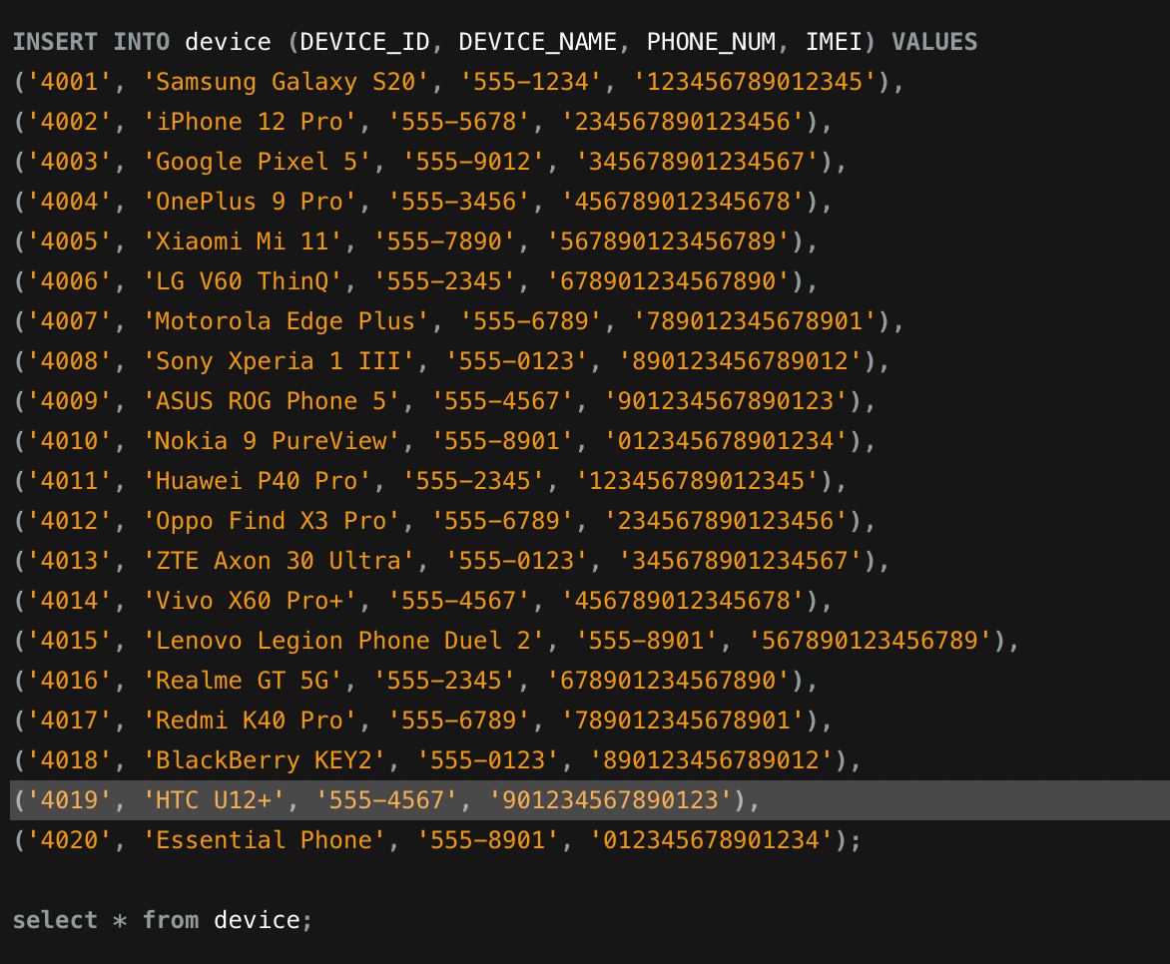

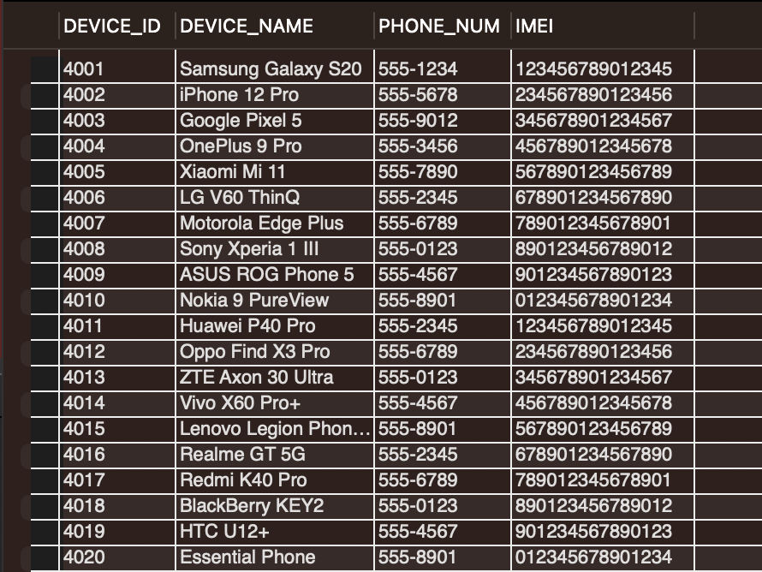

1. **Offer Table:**

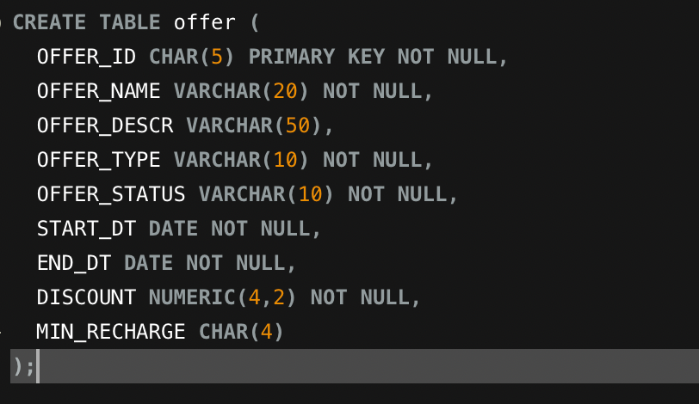

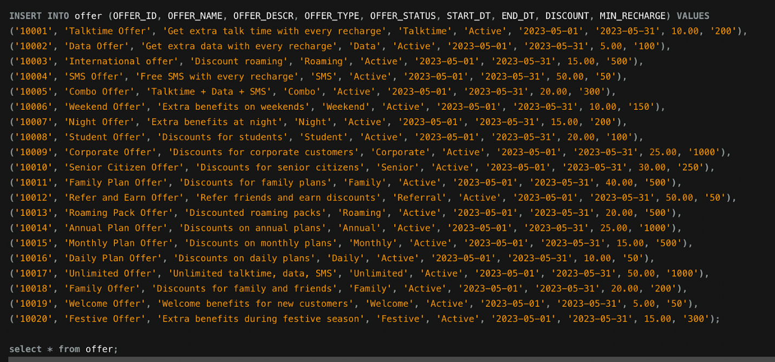

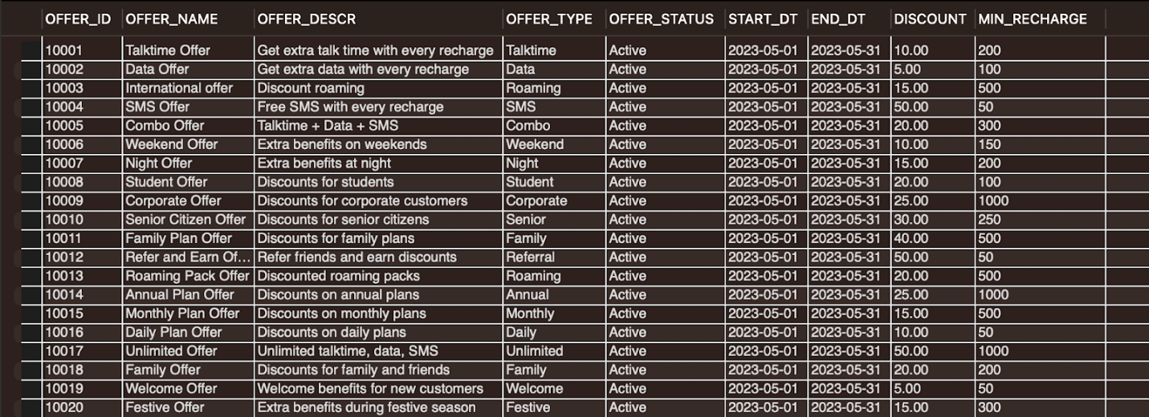

1. **Plan Table:**

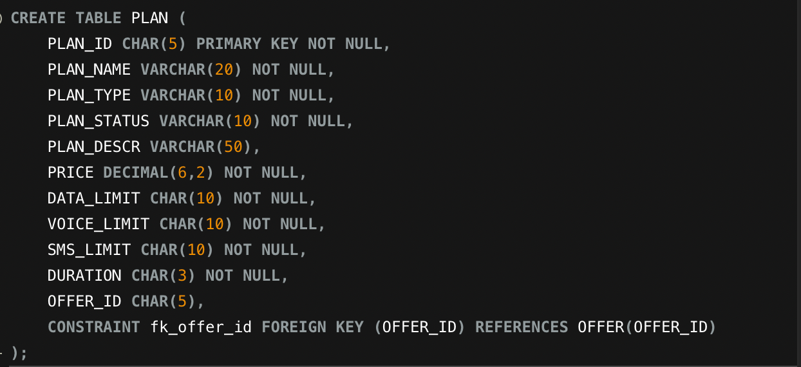

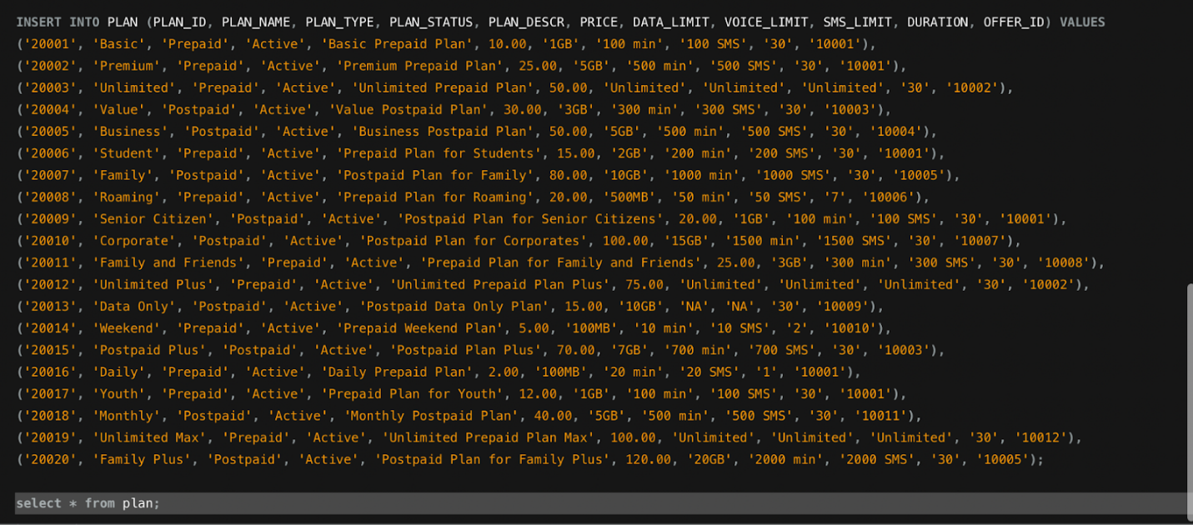

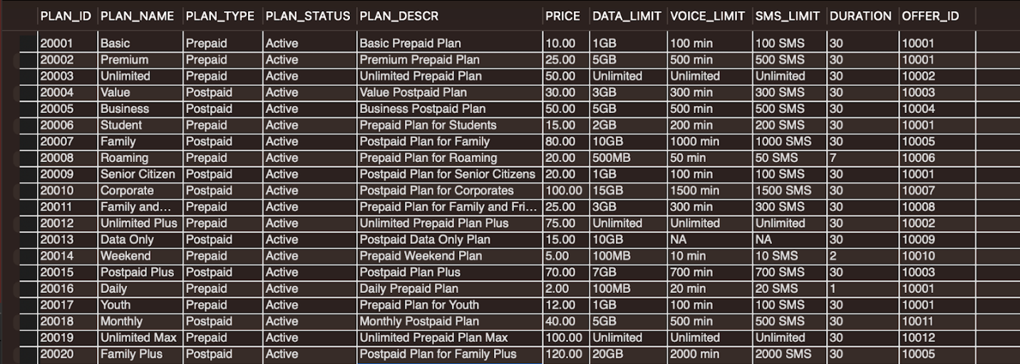

1. **Feedback Table:**

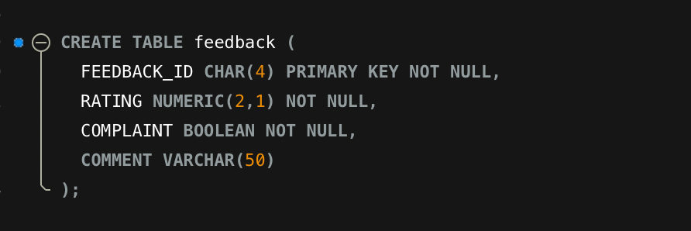

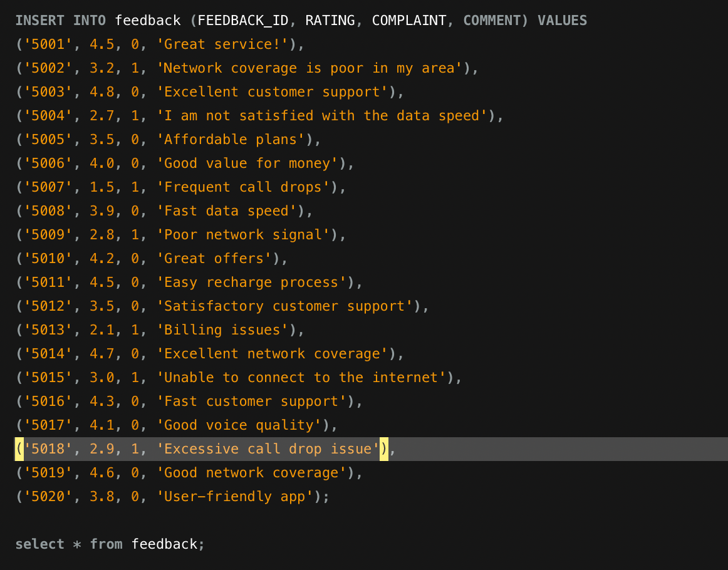

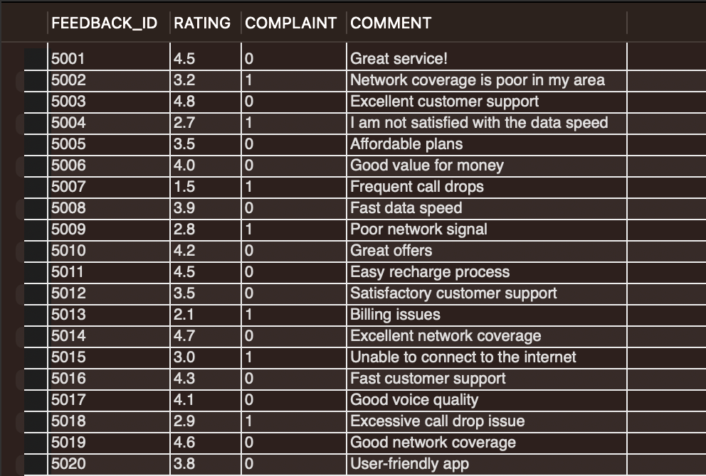

1. **Customer Table:**

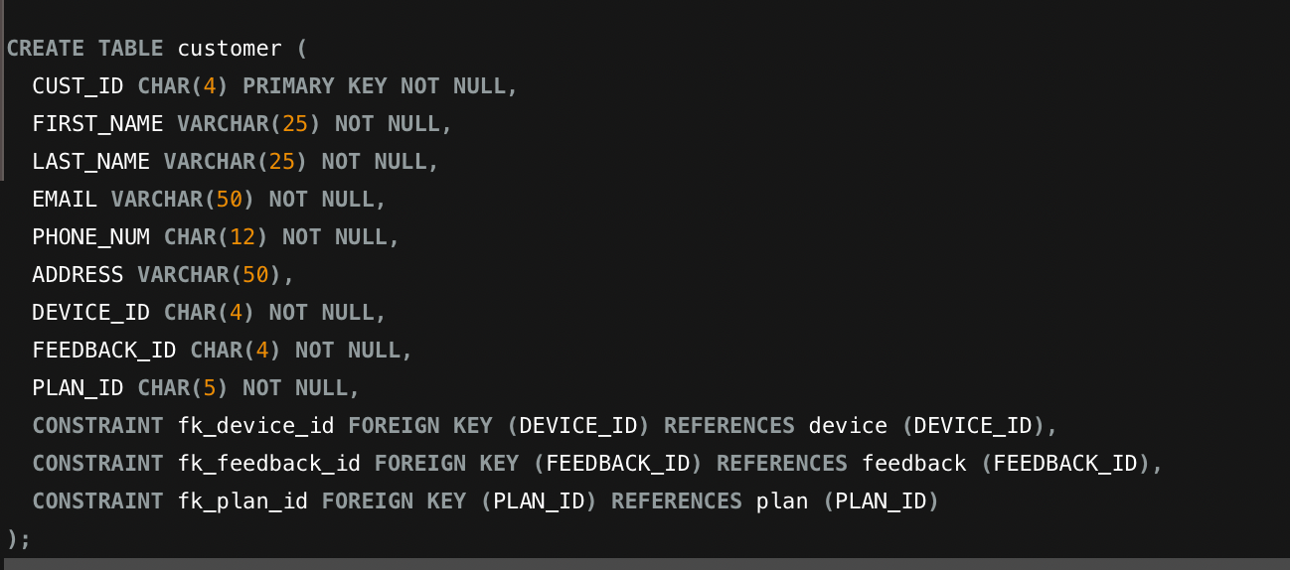

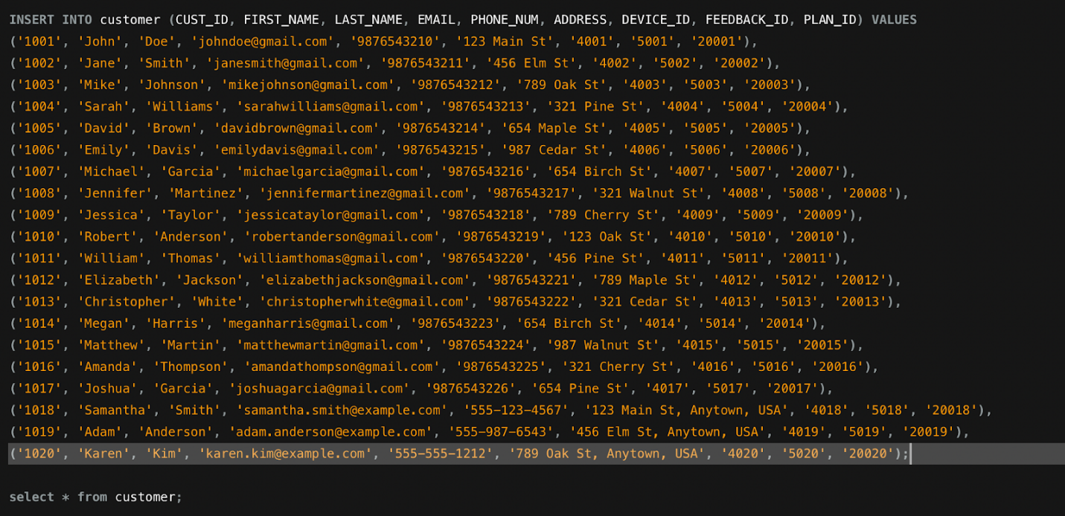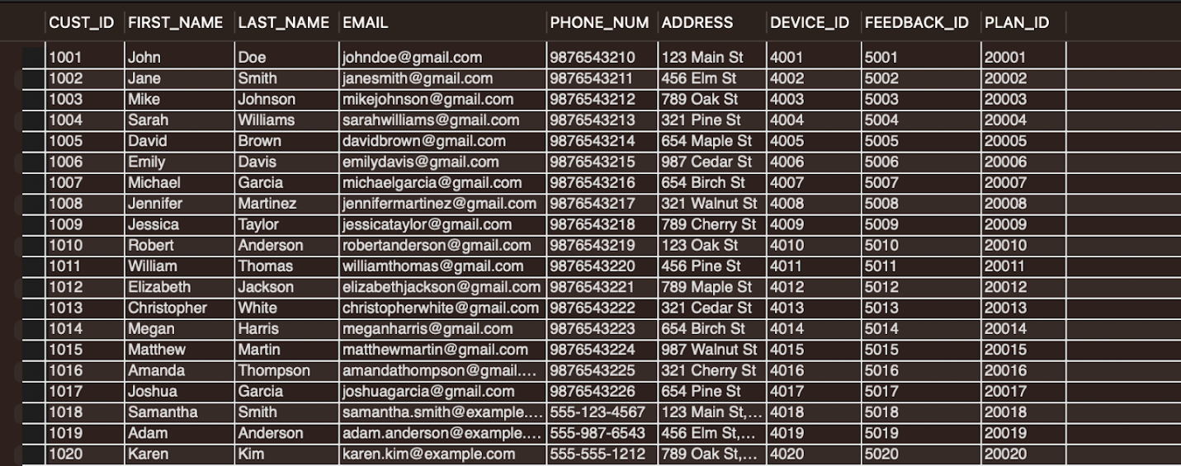

1. **Billing Table:**

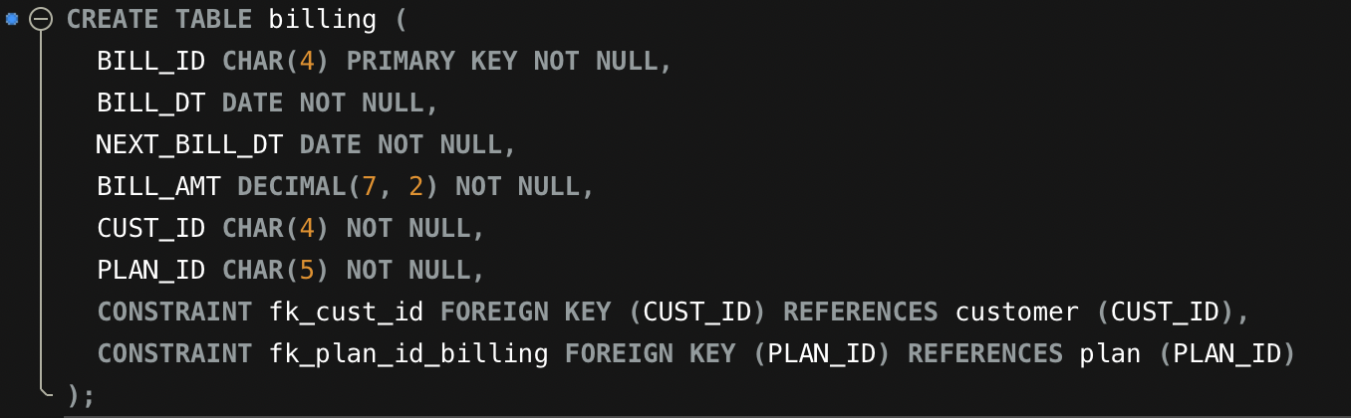

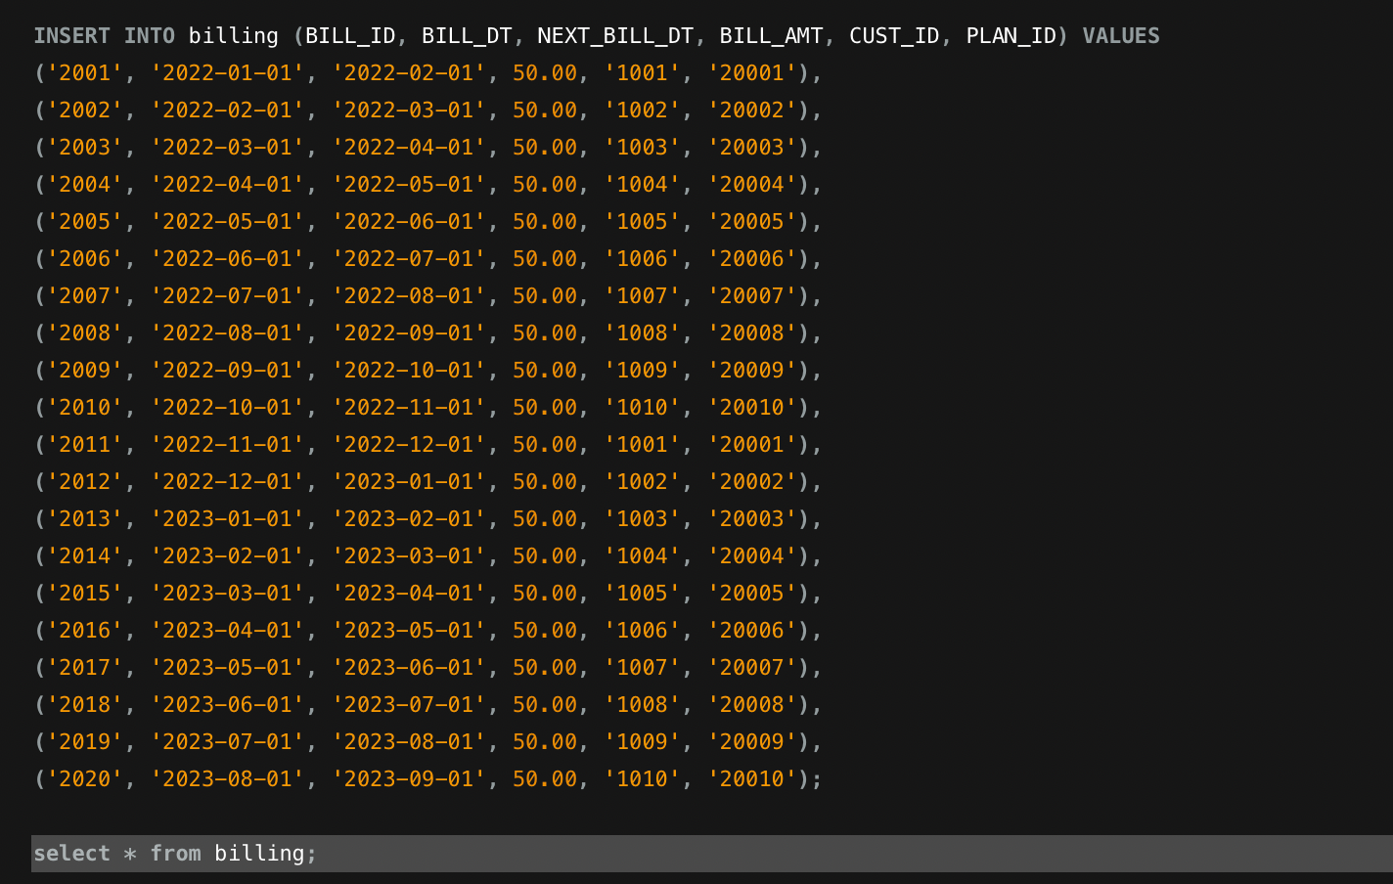

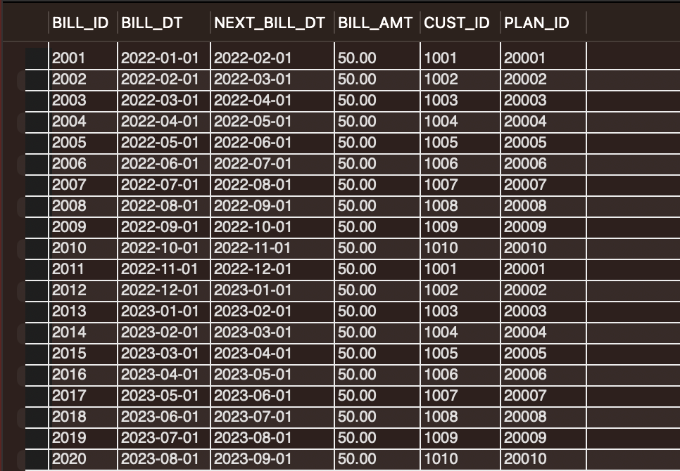

1. **Invoice Table:**

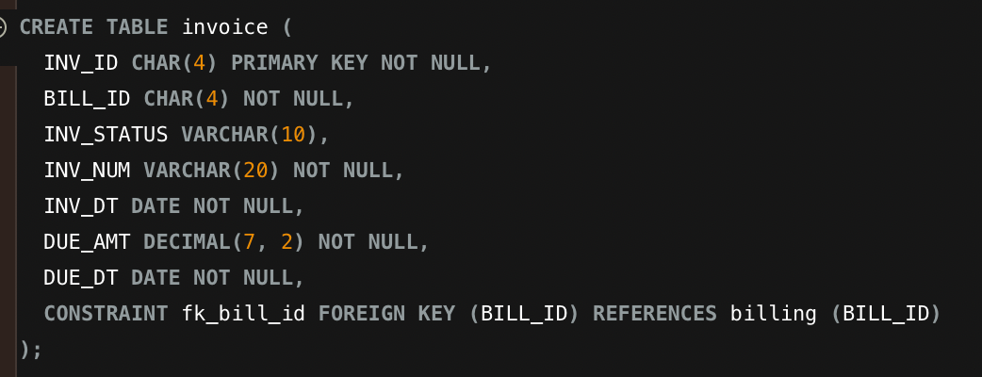

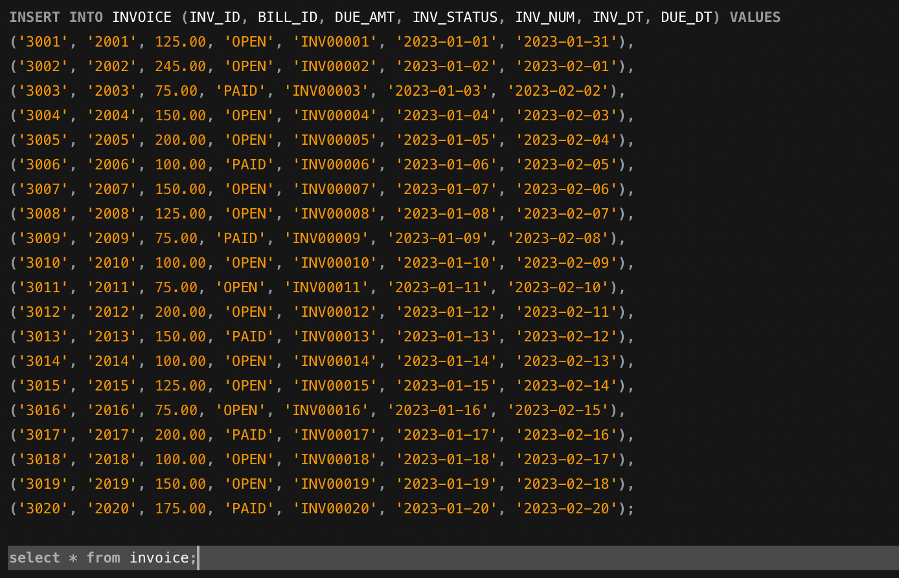

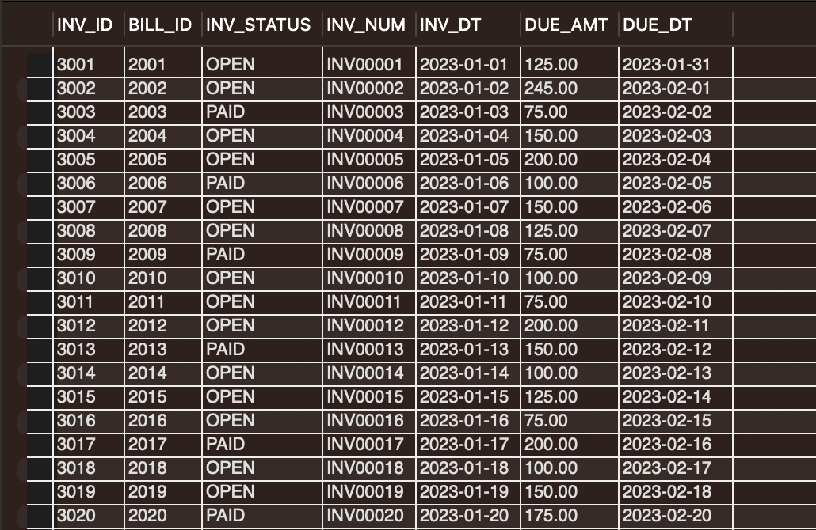

1. **Usage Table:**

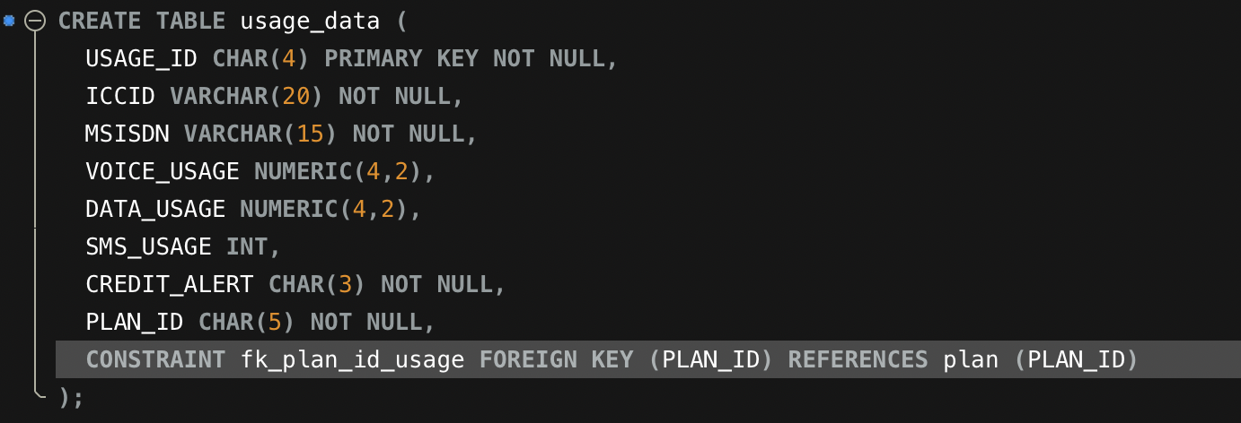

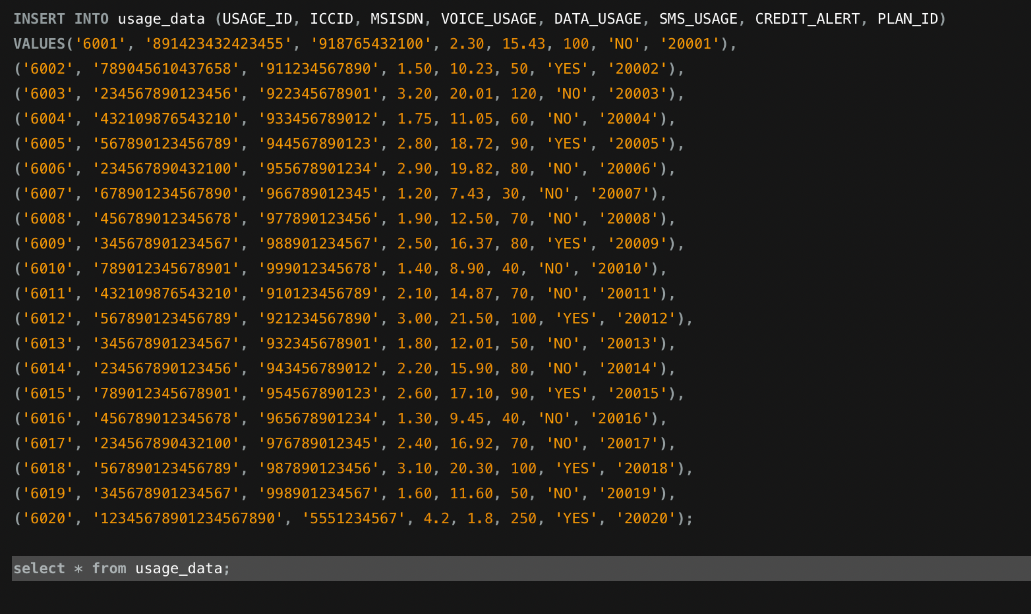

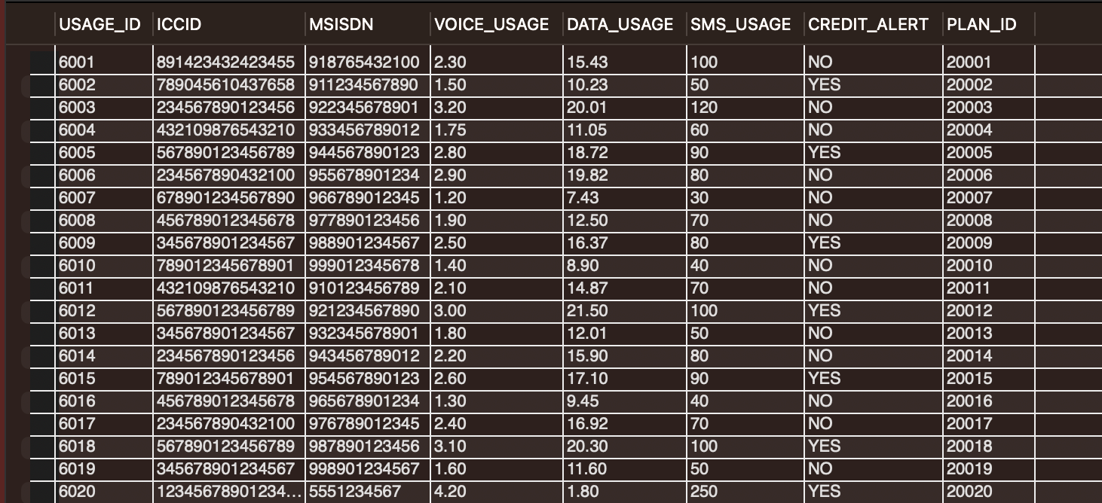

1. **Backlist Table:**

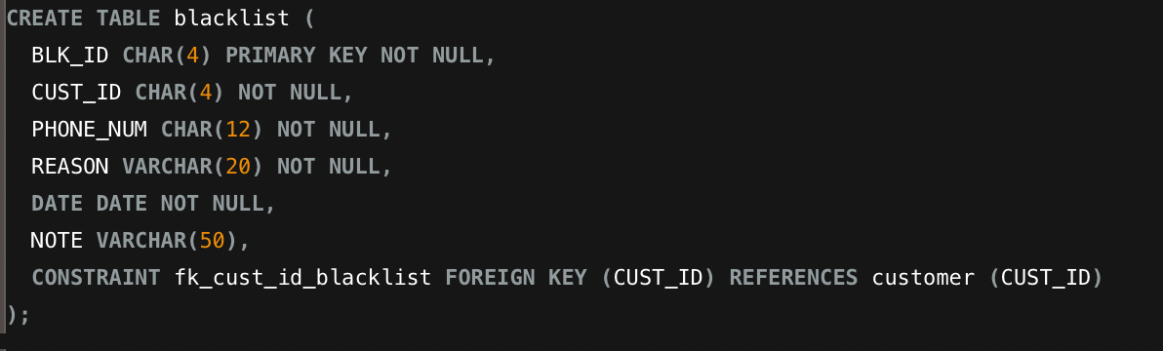

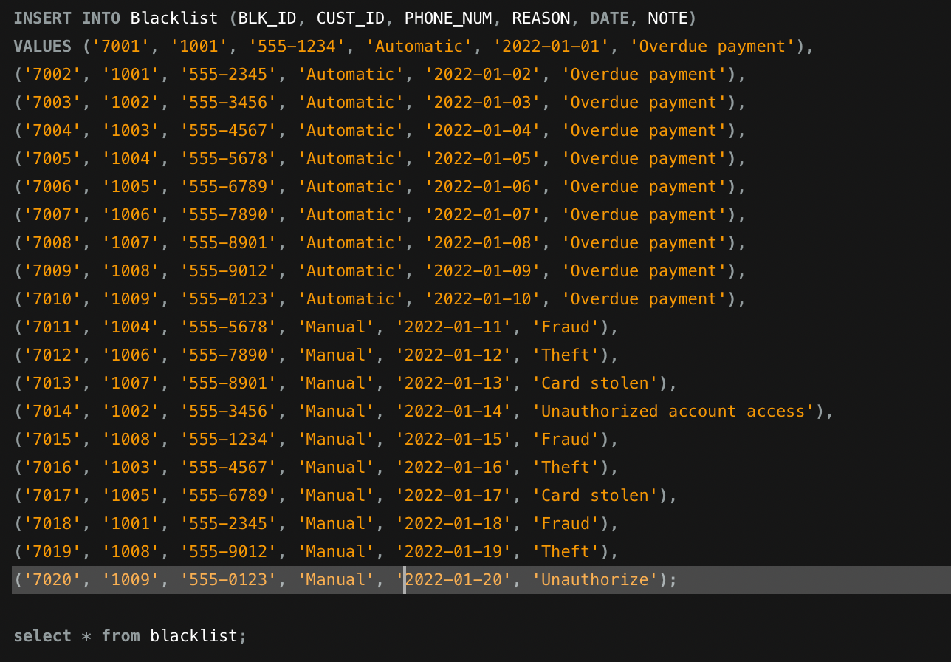

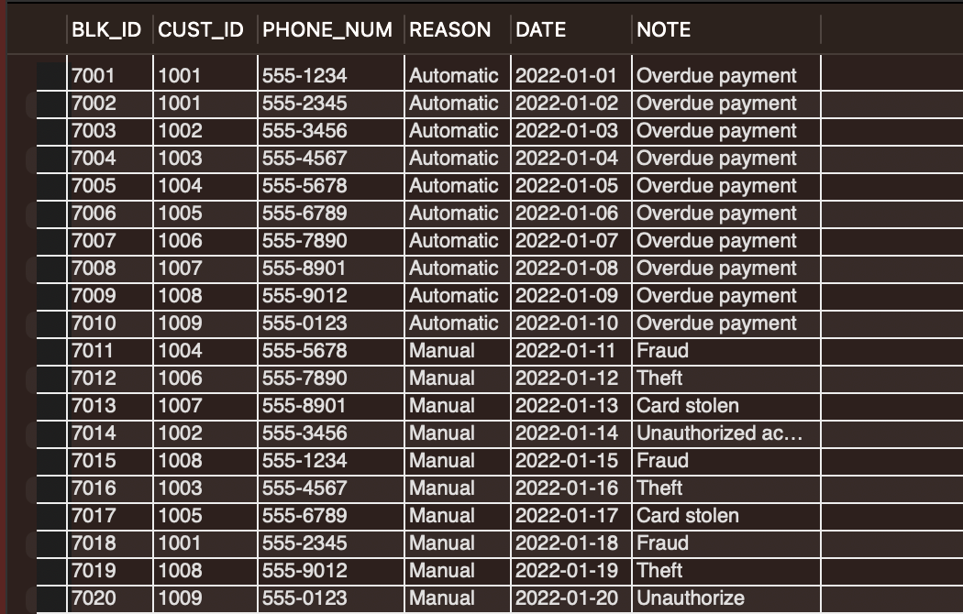

1. **Department Table:**

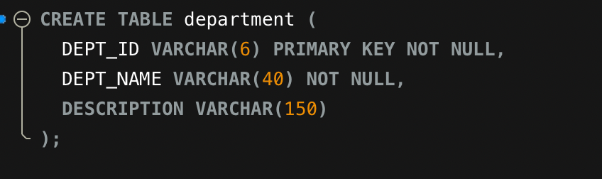

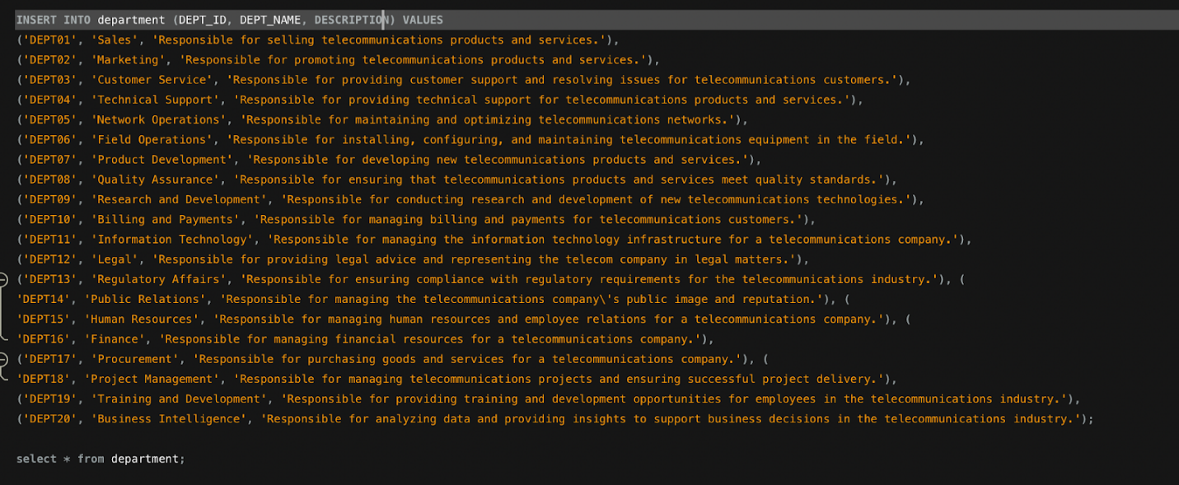

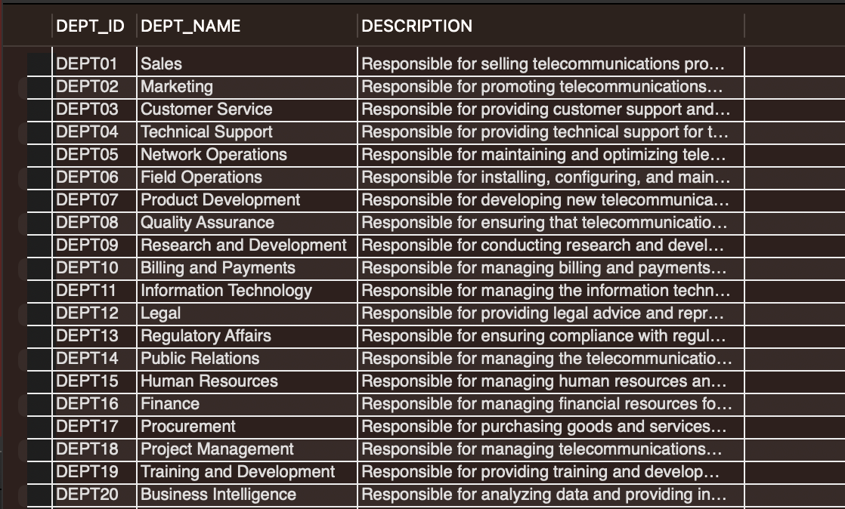

1. **Employee Table:**

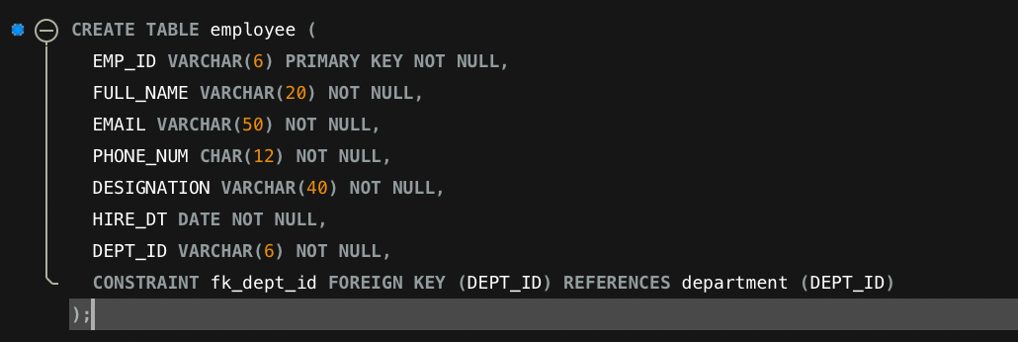

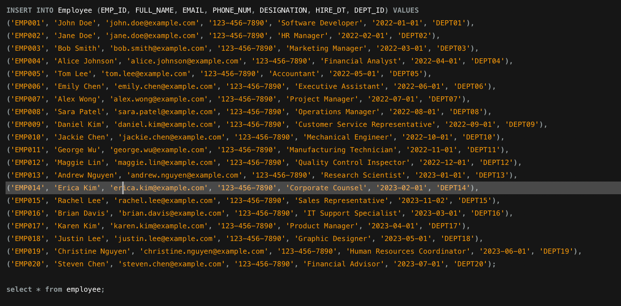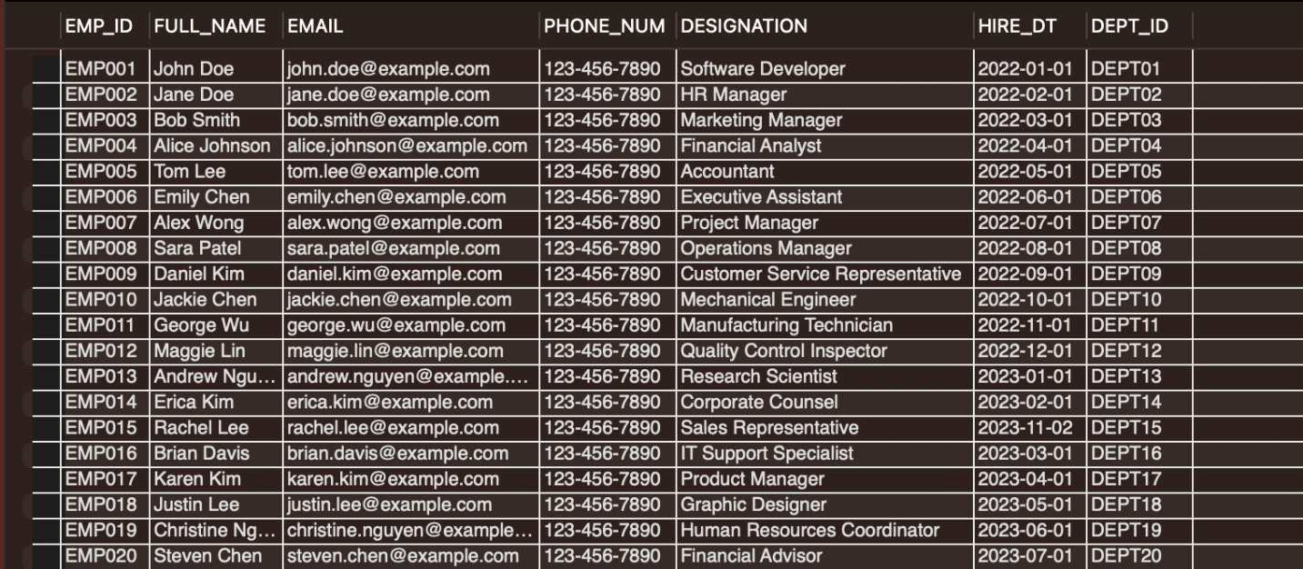

1. **Plan_Offer Table:**

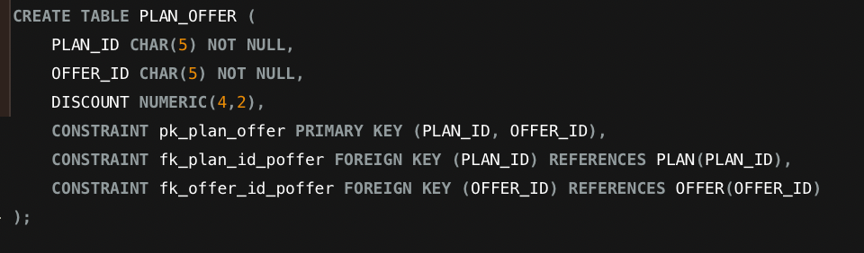

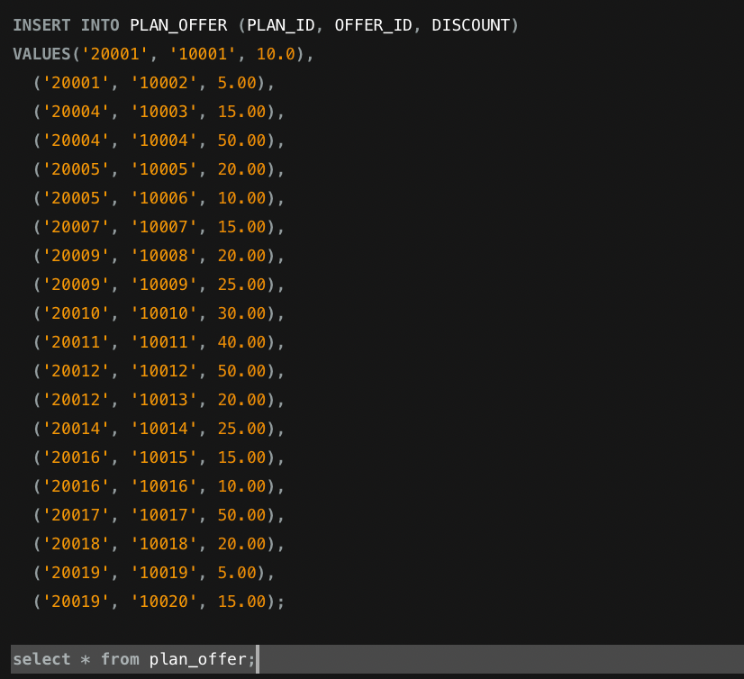

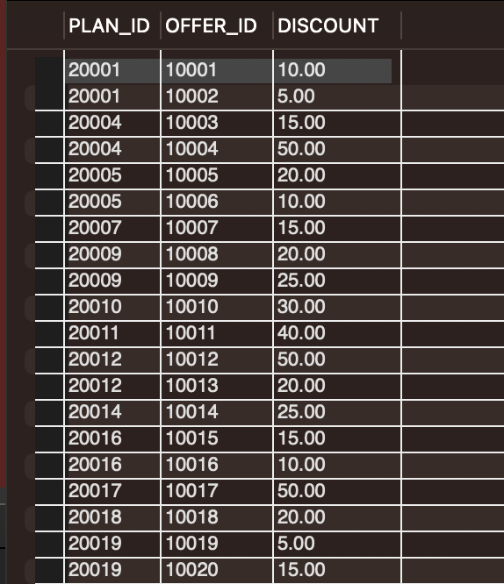

1. **CUST_EMP Table:**

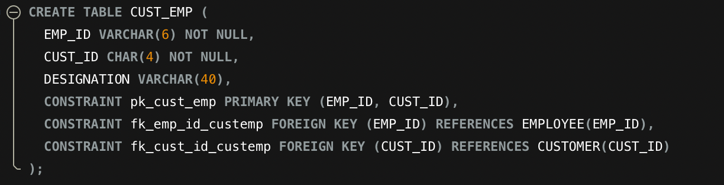

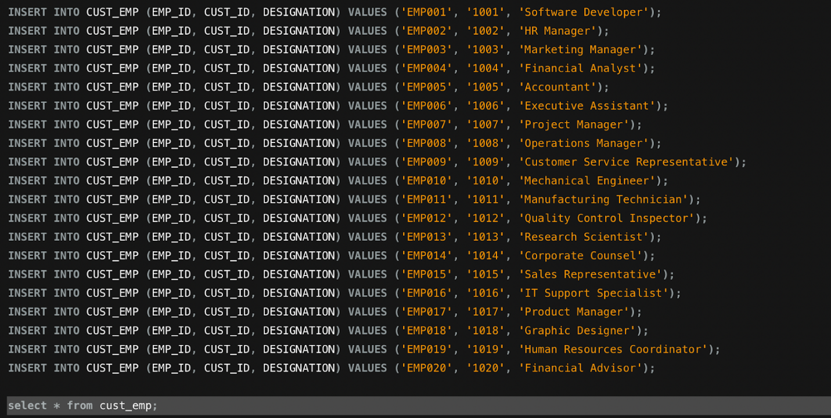

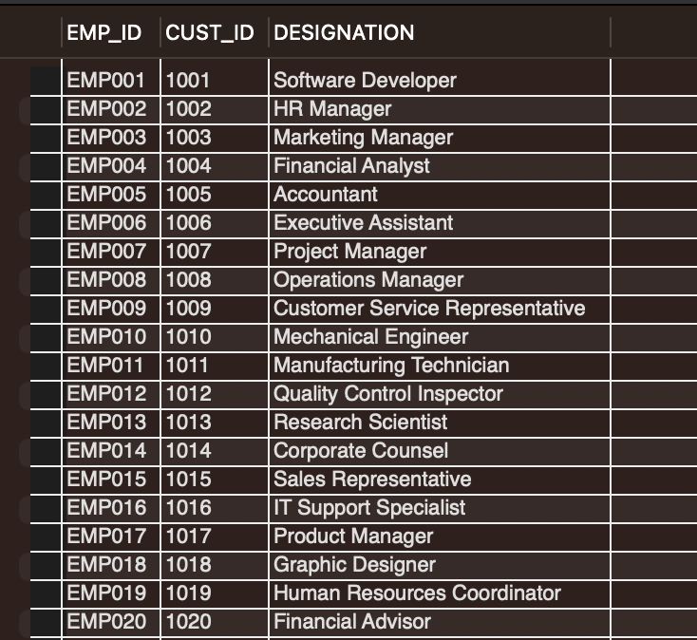

1. **Payment Table:**

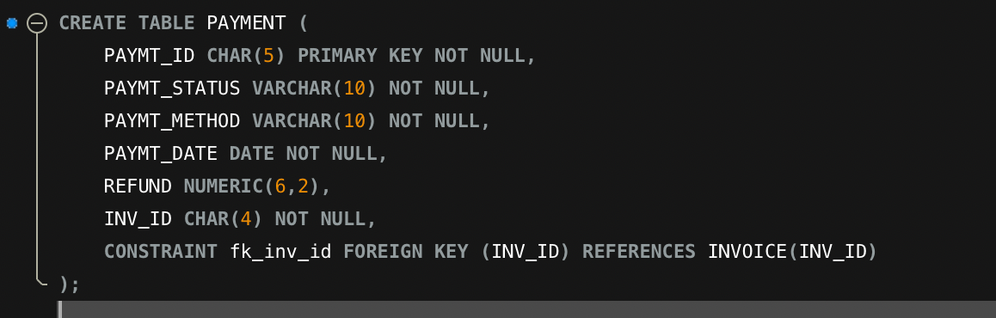

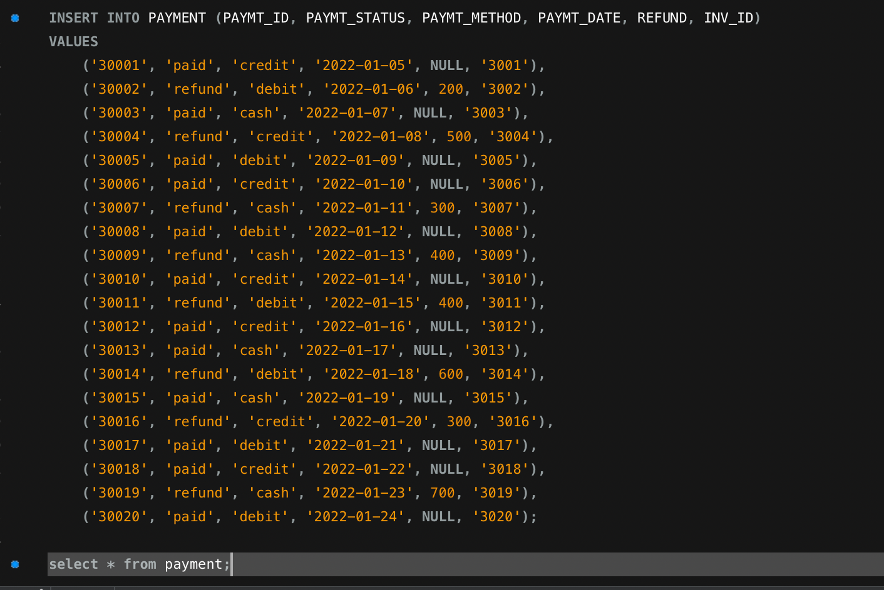

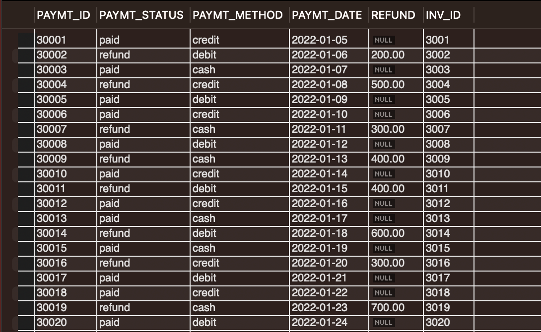

**Trigger Commands:**

**1. For IMEI Validation.**

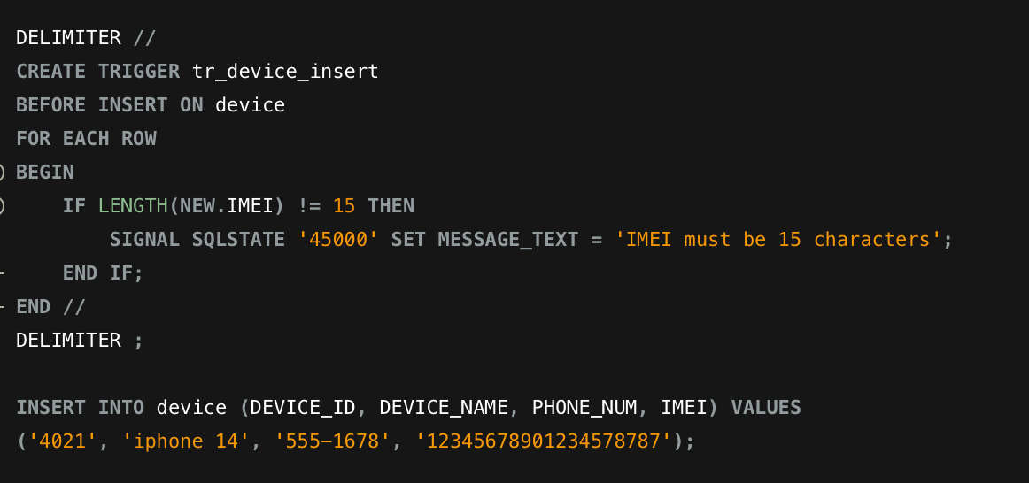

**Output:**

03:39:51 INSERT INTO device (DEVICE_ID, DEVICE_NAME, PHONE_NUM, IMEI) VALUES('4021', 'iPhone 14', '555-1678', '12345678901234578787') Error Code: 1406. Data too long for column 'IMEI' at row 1 0.0056 sec.

**Explanation:**

**If a consumer or customer representative enters an IMEI number with more than 15 digits, the system will issue an error stating that the IMEI number is too long. This trigger command is more beneficial for avoiding duplicate data in a table.**

**2. Payment Information validation:**

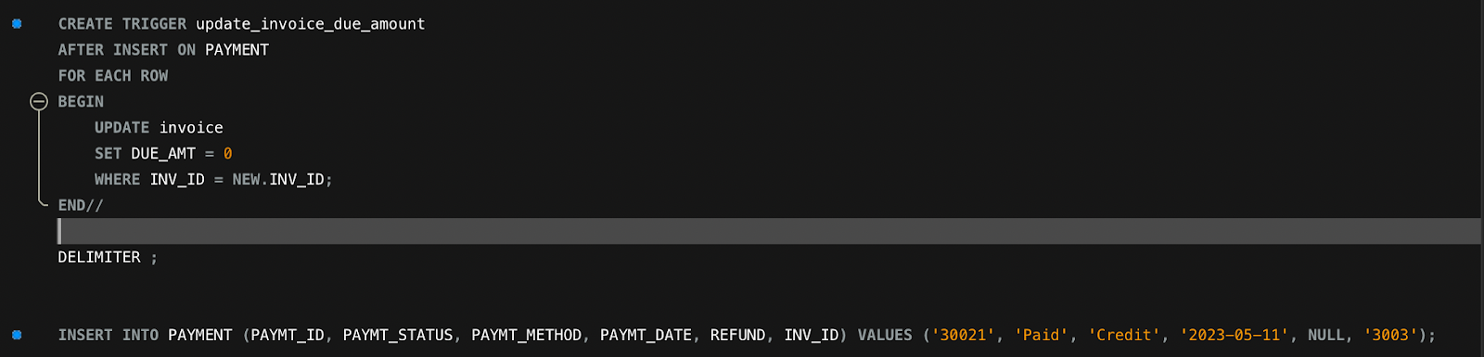

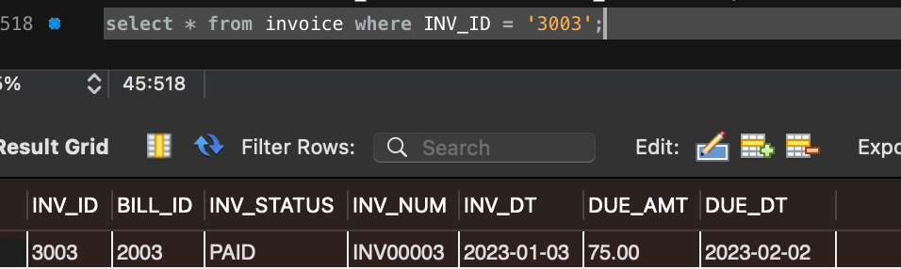

Here due amount is 75.00 as mentioned in the preceding table. This is due for invoice “3003”.

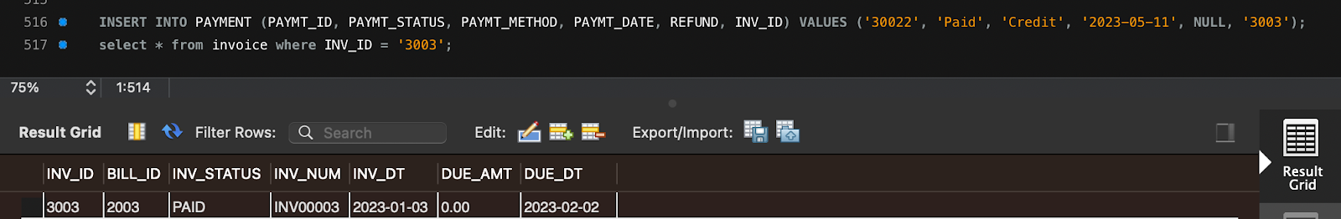

Explanation:

We've created a trigger command that updates the due amount to zero in the invoice table whenever a new payment table entry is associated with an invoice. Once payment has been received and recorded in the payment table, this trigger command would help automate the process of revising the invoice status to paid.

**Data Retrieval & Simple Reports:**

Q1. List all customers and their associated plan details, including plan name and price.

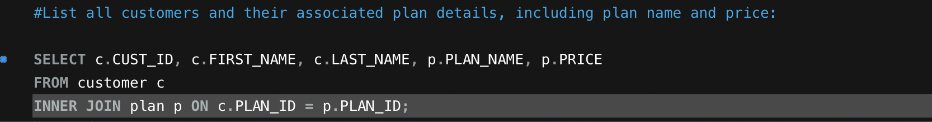

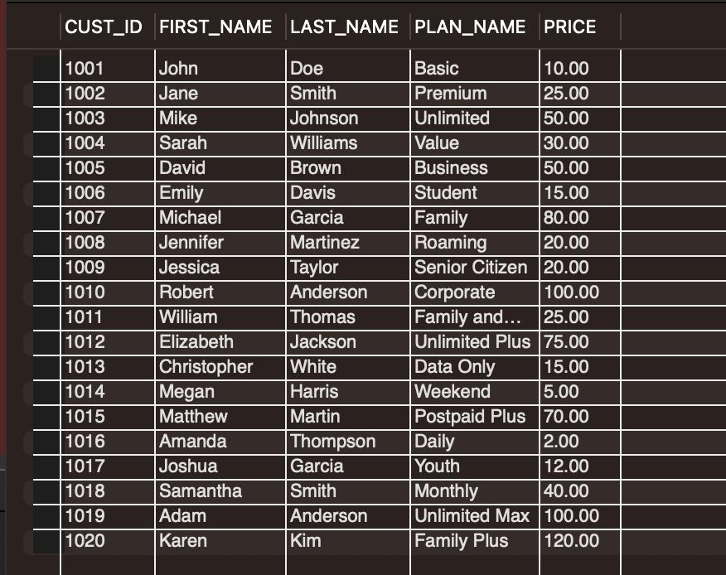

This Query lists all active customers along with their associated plan information, including plan name, price, and customer name.

Q2. List all customers who have complained in their feedback.

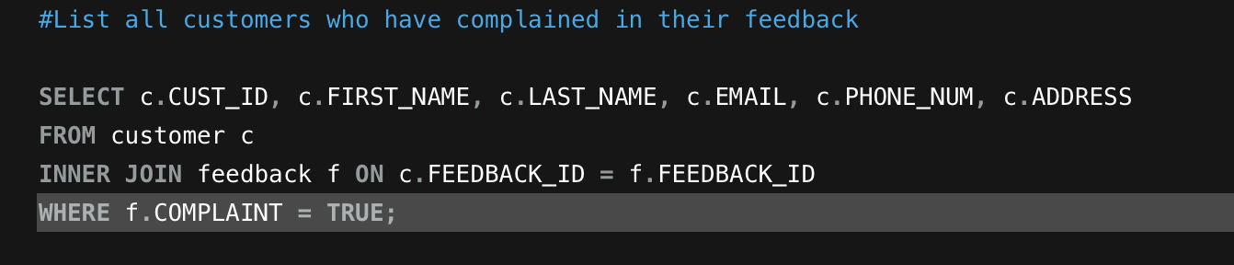

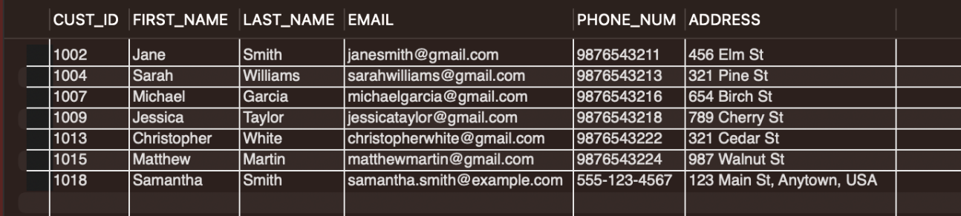

This query will display all customers who have filed a complaint regarding their telecommunication management system-provided services.

Q3. List all customers who have a billing amount greater than or equal to 50

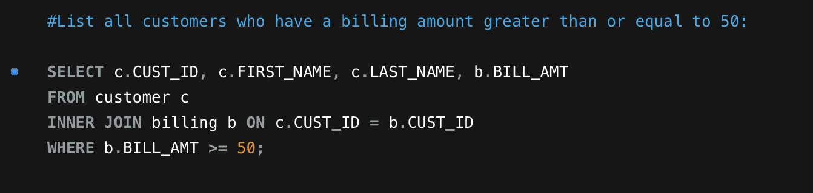

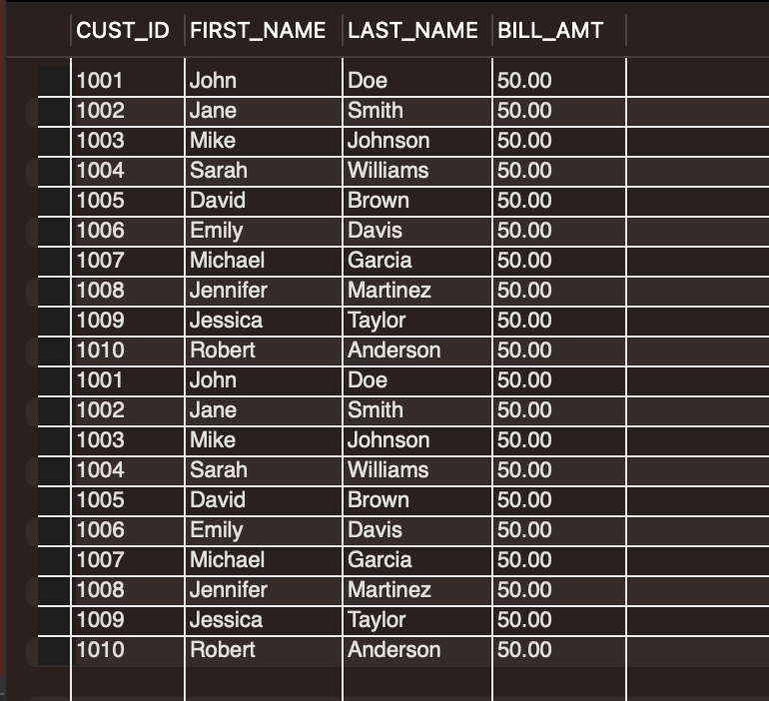

This provides details about customers whose invoicing amount is at least 50.

Q4. Retrieve the total amount billed and the total number of invoices generated for each customer.

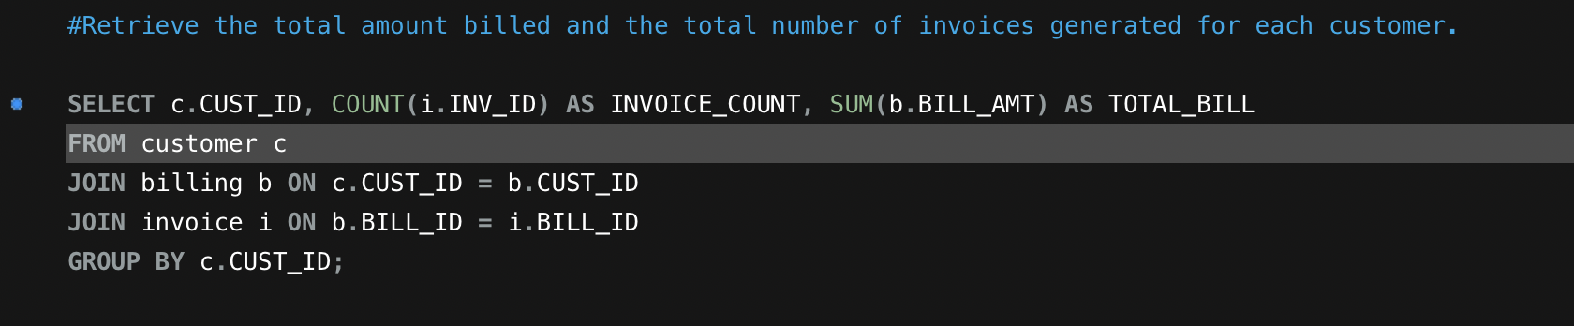

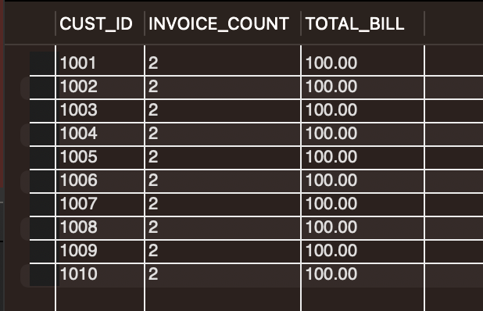

**It includes the customer's number of invoices and total outstanding balance.**

Q5. Which plans have a discount offer currently active?

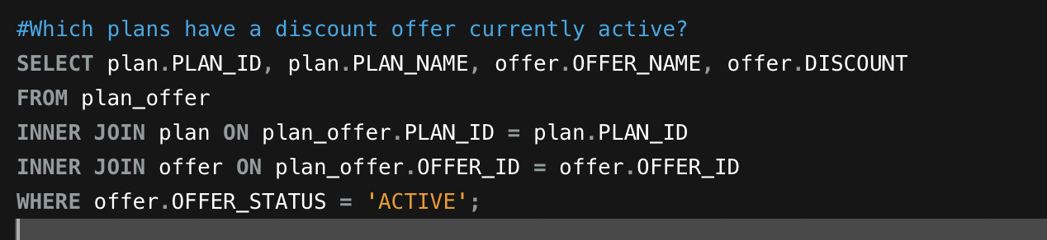

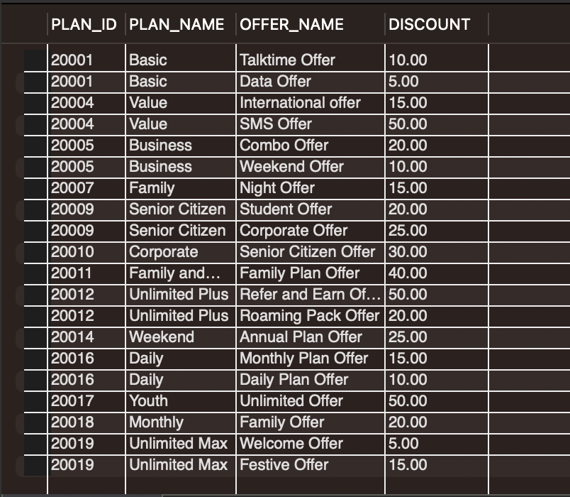

It contains information about the client who took advantage of the discount offered by the telecommunications provider.

Q6. How many customers subscribe to each plan?

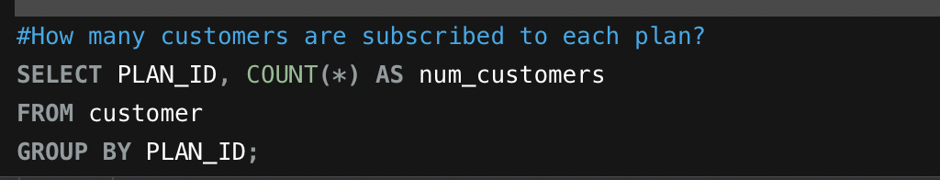

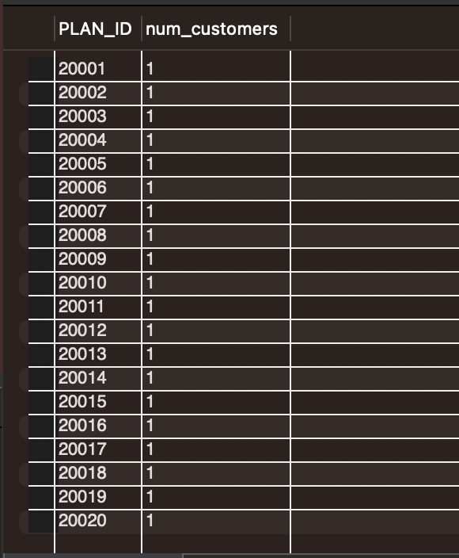

**It contains information about the number of customers who have signed up for each plan.**

**Future Scope:**

* The application of blockchain technology to data security, data integrity, and data privacy is possible. Additionally, it provides a clear record of all activity.
* Customers can use mobile applications to view their daily or monthly telecommunications service usage and to purchase new plans directly from the application.
* In addition, based on their Usage and activity patterns, we can provide them with a more effective future. This section is primarily about Machine Learning.
* The database can be linked to third-party services such as Netflix and Amazon to provide customers with improved plan options. This means that consumers can purchase a plan that includes these benefits.
* Using middleware, other network provider companies can access a database, which is advantageous for both companies.
* Currently, consumers can only pay for their plans with a credit card or cash, but in the future, we can introduce digital wallets as a payment option.

**Contribution:**

Bhavana Sunkara (95%)

Hrushikesh Badineni (95%)

Kamini Suresh Yelamar (95%)

Narayan Dharmendra Raval (95%)

Swathi Pasham (95%)